
3DMLGO 1234
SECTION

3D MARINE LOGISTICS GROUP ORDER/BULLETIN 1234

From: Title of Activity Head and Command Name
To: Distribution List
Via: (1) Title of Activity Head and Command Name
(2) Only number if more than one via

Subj: TITLE OF DIRECTIVE IN ALL CAPS

Ref: (a) Title of reference
(b) Title of reference

Encl: (1) Separate documents attached to the directive
(2) Always number enclosures (even if just one)

1. Situation. This paragraph provides a brief explanation of any background information pertinent to this directive.

2. Cancellation. 3DMLGO ###### Former Directive that was cancelled prior to this one (If applicable to order, a cancellation is not required for a Bulletin)

3. Mission. This paragraph clearly and concisely states what this directive is intended to accomplish.

4. Execution.

a. Commander’s Intent. This paragraph will elaborate on the “mission” paragraph with the
commander’s personal expression of the purpose of the order and give the desired end state.

b. Concept of Operations. This paragraph provides an overview of how the commander plans to accomplish the mission. This answers the who, what, where, when, and why questions.

c. Subordinate Element Missions. This paragraph tasks individual sections, units, etc. with duties and responsibilities required to complete the subject mission.

d. Coordinating Instructions. Provide instructions that pertain to multiple units simultaneously or require the coordinated actions of multiple units.

5. Administration and Logistics. Provide points of contact and other available sources of information and support.

6. Command and Signal

a. Command. Label the units to which this Directive applies.

b. Signal. State when the Directive will be effective.

I. M. MARINE

Distribution: X

How to set tabs on directives:

Step 1: To set a tab, right-click on the margin where the writing begins, select “Paragraph…
2
1

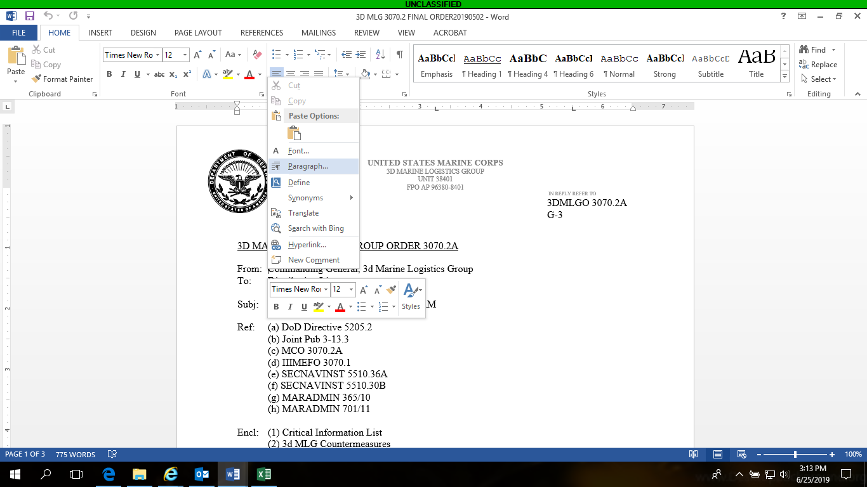

Step 2: Then on the bottom left hand corner, select “Tabs”. Ensure you select “Clear All” and then set your tabs accordingly.

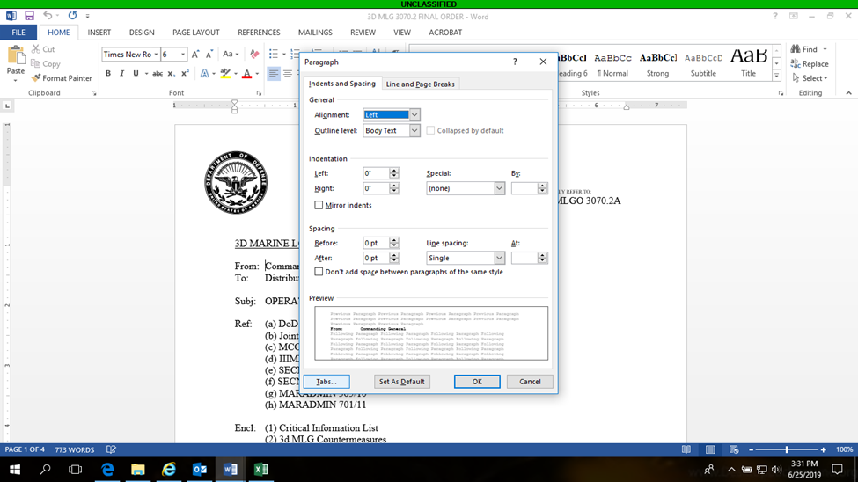

Step 3: Ensure you select “Clear All” and then set your tabs according to the format of your directive.

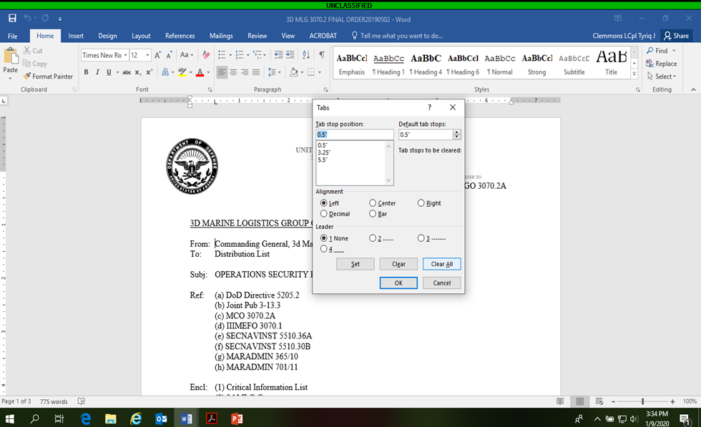
3

Step 4. (Directive tabbing below)

Header Tabbing:

Step 1: Ensure that the Seal is one inch in diameter and 0.5 inches from the right side and the top of the page.

Step 2: Ensure the “UNITED STATES MARINE CORPS” portion will always be in Times New Roman 10-point font in all capitals. Also, make sure the Unit Address is in Times New Roman 8-point font in all capitals.

Step 3: Ensure that the Header is 0.5 inches from the top of the page, and that the Footer is 0.5 inches from the bottom of the page (Use the insert tab to input this information).

Step 4: Ensure “IN REPLY REFER TO:” is in Times New Roman 5-point font.

Step 5: Ensure everything else below “IN REPLY REFER TO:” will be in Times New Roman 12-point font (including the SSIC Block and Section Symbol). The font size can vary from 12, 11.5, or 11. You will only need to change the font size if the signature page drags along to a new page rather than being at the bottom of one.

Order Format:

Step 1: Everything before the very first paragraph (the ‘From:’ line to the last ‘Enclosure:’ line) is set to the 0.5 and 0.75 tab

Body:

Paragraph spacing (applicable to Orders, Policy Letters, and Bulletins). Paragraphs are indented by setting tabs for each level of sub paragraphing (To set a tab, right-click on the margin where the paragraph begins, select “Paragraph…”, then on the bottom left hand corner, select “Tabs”. Ensure you select “Clear All” and then set your tabs accordingly):

1. No spacing needed

a. Set tab to .22 (one tab)

(1) Set tab to .42 (two tabs)

(a) Set tab to .66 (three tabs)

1. Set tab to .90 (four tabs)

a. Set tab to 1.12 (five tabs)

(1) Set tab to 1.32 (six tabs)

(a) Set tab to 1.56 (seven tabs)

3.25 for signature block

